Ein Bild, das Logo, Symbol, Schrift, Grafiken enthält.

**Augmented reality and mobile Addon for the car repair shop of Martin & Weber**

**based on a repair and documentation support System**

Project Report  
by  
**Team-No. 4**  
Matriculation number: 11038520

2024-07-15

SRH University Heidelberg  
School of Information, Media and Design  
Degree course: M.Sc. Applied Computer Science

Reviewers Prof. Dr.-Ing. Gerd Moeckel

Dr. Josef Hermanns

**Table of Contents**

1 Introduction 5

1.1 Team Roles and Responsibilities 5

1.2 Project Environment 6

1.3 Project Description 6

1.3.1 Project Overview 6

1.3.2 Project Objectives 6

1.3.3 Target Group 6

2 Target State 7

2.1 Target Classes 7

2.1.1 High-level Objectives 7

2.1.2 Result Objectives 7

2.1.3 Process Objectives 8

3 Analysis 10

3.1 Requirement Analysis 10

3.1.1 Additional Information from Stakeholders 11

3.2 Stakeholder Analysis 11

3.2.1 Identification and Evaluation of Stakeholders 12

3.2.2 Stakeholder Map 13

3.3 Chance and Risk Analysis 13

3.3.1 Risk Analysis 14

3.3.1 Chances and Opportunities 16

3.3.2 Legal Aspects 16

3.4 Technology Aspects 17

3.4.1 Features 17

3.4.2 Functionalities 18

3.4.3 Capabilities 19

3.4.4 Potential Impact: 19

3.5 Usability Requirements 20

4 Design of the AR Support System 22

4.1 Preconditions and Expectations 22

4.2 User Interface Design 22

4.2.1 Mobile Devices 22

4.2.2 AR-Headset 24

4.3 Usability and User Experience 26

4.4 Technological Design 26

4.4.1 Selecting the Right Hardware 27

4.4.2 AR Software 27

4.4.3 Integration with existing systems 27

4.4.4 Ensuring Compatibility and Performance 27

4.4.5 Addressing Security Concerns 28

4.4.6 Providing Technical Support 28

4.5 Test Scenarios 28

4.5.1 Unit tests 28

4.5.2 Components tests 29

4.5.3 Integration Tests 29

4.5.4 System Tests 29

5 Project Planning 30

5.1 Project Management Methodology 30

5.2 Execution Methodology 31

5.3 Controlling Methodology 32

5.4 User Stories and Epics 33

5.5 Project Structure and Network Plan 34

5.5.1 Product Structure Plan 34

5.6 Sprints 35

5.6.1 Sprints for mobile Development 35

5.6.2 Sprints for Augmented Reality 36

5.7 Time Planning 37

5.8 Budget Planning 39

5.9 Stakeholder and Risk Management 40

6 Executive Summary 42

Appendix 43

A. Personas 43

B. Use Cases: Usage Flow of mobile App 45

C. Use Cases: Usage Flow of AR-Headset 46

D. Technical Risks 47

E. Project Environment Risks 47

F. Safety Risks 48

G. Business Risks 49

H. Planning Risks 50

I. Environmental Risks 51

J. Risk Classification and Mitigation Strategies 52

K. Epics – Mobile Application 57

L. Epics – AR-Application 62

Literature and References for images 67

Index of Figures 68

Index of Tables 69

# Introduction

## Team Roles and Responsibilities

|  |  |  |
| --- | --- | --- |
| **Member** | **Technical Role** | **Chapters on report** |
| Andreas Mueller | UI/UX-Specialist, Planning & Risk Management | Introduction, Process Objectives, Stakeholder and Risk Analysis & Strategies, User Interface Design, User Experience, Time and Budget planning, Stakeholder & Risk Management, Creating Stakeholder Map, Risk Matrix & MTA Chart, Formatting and Structuring the Document & Appendix |
| Mohith Tummala | Frontend Development, Requirement analysis, UI/UX Analyst, Testing, and Risk Management. | Requirement Analysis, Application Usage flow, Personas, Use Cases, Test Scenarios, Risk Analysis occurrence and consequences, Stakeholder and Risk Analysis & Strategies, User Interface Design, User Experience, Time and Budget planning, Stakeholder & Risk Management, Reviewing and analyzing the document. |
| Pooja Patil | Project planning, Risk and stakeholder management | Requirement Analysis, Stakeholder and Risk Analysis & Strategies, Target state, Stakeholder & Risk Management, Project Planning, Project structure plan, User stories, Epics, Sprint planning. |
| Prashanth Sersani | Technology analyst | Technology aspects, technological design, usability requirements, preconditions and expectations |

Tab. 1‑1: Team Roles and Responsibilities

## Project Environment

The AR-supported repair and documentation system for Martin & Weber is designed to revolutionize how small automotive repair shops manage their services and interact with their clientele. By integrating cutting-edge AR and AI technologies, the project aims to enhance operational efficiency, customer satisfaction, and business growth for Martin & Weber.

## Project Description

### Project Overview

This project aims to develop an augmented reality (AR) supported repair and documentation addon for the "Order Management System for Car Repair Shop," specifically tailored for Martin & Weber, a small car repair shop with five employees. The system is designed to enhance the efficiency and accuracy of car repairs, particularly for both modern and classic cars, leveraging advanced AR technologies and a large language model (LLM)-supported mobile audio interface.

### Project Objectives

* **Enhance Repair Efficiency:** Streamline the repair processes with AR technologies, reducing time and improving repair quality.
* **Ease of Use:** Develop a user-friendly interface suitable for employees without specialized IT skills.
* **Automated inventory tracking and billing:** Provide an easy inventory tracking system and generate billing based on services provided and parts used.
* **Integration with Specific APIs:** Incorporate APIs for classic car communities, spare parts shops, and consultancy networks.
* **Train new employees:** Training a new employee in basic repairs via AR technologies which would avoid the cost and space required.

### Target Group

The primary users of this system will be the employees of Martin & Weber, particularly mechanics who handle various types of vehicles, including classic cars. Secondary users include other potential car repair shops with whom there is a possibility of having service contracts.

# Target State

Our client, Martin & Weber, is a small car repair shop with three employees who work on all types of cars, including classic cars. It should aim to provide a simple and user-friendly system that requires only short training modules. It will be a comprehensive project management package that includes research, selection of suitable technologies, architecture design, and user interface design. It should be an AR-supported repair and documentation system for current and classic cars with all the necessary functionalities and more.

## Target Classes

### High-level Objectives

We aim to create a straightforward and easy-to-use system. This system will consist of short training modules and provide a complete project management solution that covers research, technology selection, architecture, and a simple user interface design. The system will be designed to support Augmented Reality and will serve as a repair and documentation tool for both modern and vintage cars. It will have all the necessary functionalities to solve the challenges of our customer.

### Result Objectives

|  |  |  |
| --- | --- | --- |
| **Package** | **Features** | **MOSCOW** |
| **Basic** | We **must** have a Smartphone API | Must |
|  | We **must** have Large Language Models | Must |
|  | We **must** have a decent database for saving all information | Must |
|  | We **must** have bill generation based on completed service and parts used | Must |
|  | We **should** have training for new employees via videos | Should |
|  | We **should** allow technicians to visualise complex repair procedures step-by-step with no interaction | Should |
|  | We **should** have search and order spare parts functionality | Should |
| **Premium** | We **must** have AR glasses API | Must |
|  | We **must** have Large Language Models | Must |
|  | We **must** have a database for saving all information incl. AR-Data | Must |
|  | We **must** have bill generation based on completed service and parts used | Must |
|  | We **should** provide training for a new employee in basic repairs via AR which would avoid the cost and space required. | Should |
|  | We **must** allow technicians to visualise complex repair procedures step-by-step in an interactive AR environment | Must |
|  | In case of any change/physical modification, we **could** show the customer via AR how the product would look like before implementation | Could |
|  | We **could** have object-tracking functionality | Could |
|  | We **could** provide a safety check for the employee before he starts working | Could |

Tab. 2‑1: Result Objectives Table

### 2.1.3 Process Objectives

Several key process objectives for the AR add-on project have been defined in this section. These objectives focus on aligning technical development with strategic business objectives to ensure successful implementation and operational efficiency:

Effective project management and coordination form the basis of the project by creating a precise project management framework with detailed timelines, budget allocations and resource management. The implementation of agile methodologies enables iterative development and continuous feedback, ensuring adaptability and alignment with evolving business requirements.

Compatibility with AR glasses and mobile devices will be ensured through comprehensive API integrations with third-party services to ensure seamless functionality. For support and training, we develop and deliver training modules for new and existing employees to shorten the learning curve with the new technology. Ongoing support and updates are also provided to ensure the system remains effective and relevant.

In quality assurance and testing, we conduct extensive testing, including component, integration and system testing to ensure reliability and functionality prior to full implementation. A feedback loop is established with end users to continuously improve the system based on real-world usage and challenges.

Stakeholder engagement and communication is also key. Open communication is maintained with all project stakeholders, including technical teams, management and end users, to ensure expectations are managed and met. Stakeholder analysis is used to shape communication strategies and project outcomes that meet the diverse needs and preferences of all project stakeholders. In terms of compliance and security, comprehensive security measures are implemented to protect sensitive data and ensure compliance with relevant regulations and standards. All legal and ethical implications related to AR technology and data usage are monitored and managed.

These process objectives are designed to ensure that the project is completed on time, within budget and meets or exceeds all technical and business expectations.

# Analysis

This section of the third chapter details the project's requirements. Subsequently, these requirements are elaborated and detailed to establish a base for the project specifications.

## Requirement Analysis

We would offer Martin & Weber a choice of two packages based on their needs and budget:

**Standard Package**

* Our basic package will be affordable and include the following features.
* Smartphone API which is designed with augmented reality and is easy/cost-effective to use directly on the employee’s Mobiles or iPads.
* Large Language Models (LLM) is the required Algorithm that’s equipped to Summarize, Translate, Predict, and generate human-sounding text to convey ideas and concepts.
* Database storage for mobile Solution which is used to store all the data required for the Car service and can add more and new data efficiently since it's expandable to 5 Terabytes.
* Search/order spare parts from the Inventory on-site from corners but it might take several weeks to Deliver.
* Generate invoices based on completed services and parts used.
* Allow technicians to visualise complex repair procedures step-by-step with no interaction.
* Training employees via videos which were frequently uploaded to the training modules as well as web shared knowledge.

**Premium Package:**

* Our premium package will cost more than the basic package, but it includes additional features.
* AR glasses API Leverage remote assistance tools to help employees with instructions on how to work with car engines and other kinds of car services.
* Additional Database for AR-Content which is more extendable than the Basic package.
* Search/order spare parts from the Inventory on-site from corners alongside delivery within a week.
* Generate invoices based on completed services and parts used.
* Allow technicians to visualize complex repair procedures step-by-step in an interactive AR environment.
* Training a new employee in basic repairs via AR which would avoid the cost and space required.
* Design and prototyping (In case of any change/physical modification we can show the customer via AR how the product would look like before implementation)
* Object tracking (usage of tools)
* Safety check for the employee before he starts working.
* Searching Bots (i.e., Voice Recorders) to fetch information from DB(Database) whether the parts are available or not.

The required Personas and Use Cases for this Analysis are in the Appendix in section A-C.

### Additional Information from Stakeholders

After the initial briefing for the upcoming project, further appointments were made in which certain requirements were discussed in more detail. It turned out that some requirements had different priorities or were even just ideas.

Based on the information and queries from the meetings with the stakeholders, it emerged that the web interface for Team 3 customers will be adopted and will be part of their basic system. The Stakeholder expressed the wish that he could choose between different packages, because it is difficult for them to estimate how high the costs will be for all functions. In addition, the APIs requested at the beginning were classified as nice to have. These include the specific ancient car spare parts store and marketplaces API, the consultancy API and specific classic car community API.

## Stakeholder Analysis

The success of the project is dependent on various stakeholders, such as the owners Martin and Weber, the workers, and new employees. It is important to consider the impact of the project on classic car customers and ensure that their needs are met.

### Identification and Evaluation of Stakeholders

|  |  |  |  |  |
| --- | --- | --- | --- | --- |
| **Stakeholder** | **Influence on project** | **Financial influence** | **Power to make decision** | **Expectations of Project Results** |
| **Martin** | High | High | High | Expect to pass on experience and knowledge to younger generations​ |
| **Weber** | High | High | High | Expect to automate the training process |
| **Frank** | Low | Low | Low | Expect to learn more about cars and repairs |
| **Shop Customer** | High | Low | Low | Expect to get modern and classic cars repaired and perform customization on demand |
| **Spare parts company** | Low | Low | Low | Expect repeat business and automated spare part orders |
| **Insurance Companies** | Medium | Medium | Low | Expect to be involved in claims processing, especially for collision repairs. |

Tab. 3‑1: Result Objectives Table

### Stakeholder Map

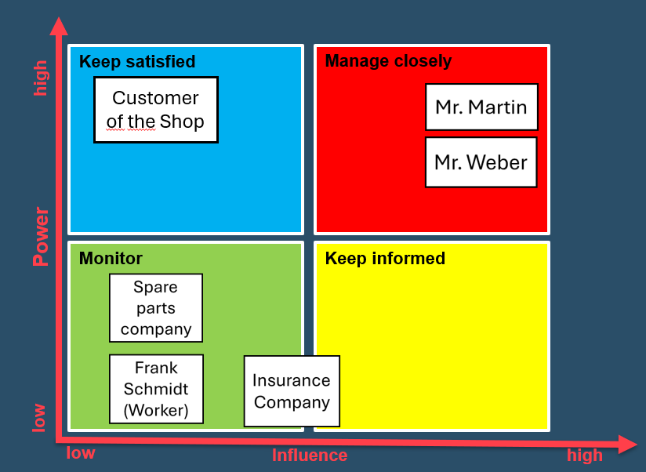

Fig. 3‑1: Main Menu and Order System Mockups

The stakeholder map provided displays all identified stakeholders and their level of influence on the project. In this case, it is vital to ensure that Martin & Weber are content with the project results, and their business objectives are considered. Moreover, it is also imperative to cater to the customer's federal and specific goals. The Spare Parts Company must be monitored, as they expect repeat business and automated spare part orders during the project. Additionally, the insurance company needs to be informed and involved in claims processing, particularly for collision repairs. This analysis is crucial for aligning the project with the needs and expectations of all involved, ensuring smoother implementation and higher chances of success.

## Chance and Risk Analysis

In this section of the third chapter, risks to the project are identified and classified. In addition, the identified risks are assessed and prioritized to prepare for the development of risk mitigation strategies. The identified risks are presented in the appendix. Figure 1 illustrates the risk matrix, which shows the identified risks in terms of their probability and severity.

The main risks identified are project risks relating to changes in decision-making authority and legal changes during the design and implementation phase. These risks are prevented through ongoing risk analyses and change management during implementation. Legal risks are classified as having a low probability of occurrence in this project. The project therefore organizes ongoing risk and change management. Further details can be found in Appendix A-F and Figure 1 of the risk matrix.

### Risk Analysis

Technical risks include the loss of the system or app connection, which can lead to errors and disrupt the current function of the car. If the AR hardware fails, important repair processes could be interrupted, which could lead to operational interruptions if there are no alternatives. Environmental project risks include changes in stakeholders or responsible persons. Other risks include a change of management in the Martin & Weber store, a change in government or undefined requirements for changes to the project environment.

Safety risks relate to the safety of tools and machines. Operating heavy machinery and cars carries risks, so regular maintenance and appropriate training, as well as safe procedures, are critical. Problems with equipment and machinery pose risks. Existing machinery and equipment indicate a risk, which can cause damage to hardware. Damage and theft are risks, as AR hardware is expensive and can be a target for theft or damage. There are also security risks in that mobile apps and AR applications make the system vulnerable and can therefore be exposed to data theft or malware. Especially if these applications are not properly secured or use insecure networks.

Business risks include unmet revenue targets due to potential competition with alternative solutions, obsolescence due to innovations in AR systems, and the complexity and potential delays of projects of this scale, which carry the risk of budget overruns and affect financial forecasts. As a result, more time than expected may be required and planned milestones may not be achieved. This can also have an impact on relationships with stakeholders.

Planning risks were also identified, such as documentation taking longer than planned, a shortage of specialists for AR development, change management processes requiring more time or necessary changes being identified during implementation and tests therefore requiring more time. Environmental risks refer to the risk of non-compliance with various environmental, safety and construction regulations, which could possibly lead to fines and project delays. Another risk is if all European or national laws and regulations have not been identified or planned for or have been misinterpreted.

The identified risks were analyzed, and the probability of occurrence determined. It was also determined how the respective risks should be dealt with and a corresponding risk balance chart was created on this basis, which is shown below. The detailed tables for each risk are in the Appendix in section D-I. The classification and mitigation table are in shown in the section J of the Appendix.

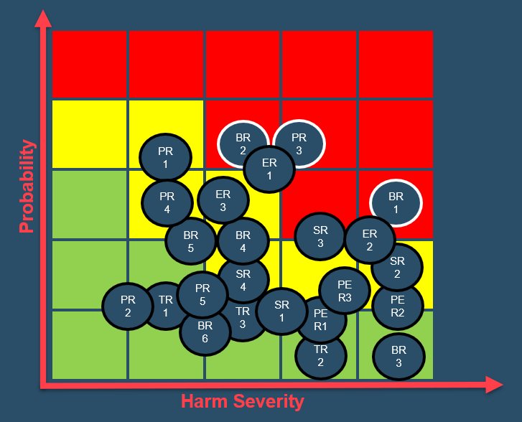

Fig. 3‑1: Risk Matrix

### Chances and Opportunities

The integration of the planned system brings several advantages and opportunities. These are outlined and explained in this section. By integrating augmented reality (AR), repair processes can be made significantly more efficient. This not only reduces repair times, but also improves the quality of the repairs carried out. The AR system enables technicians to visually reproduce complex repair procedures step by step, which is particularly beneficial for rare and classic cars. AR technology also offers innovative opportunities for training and familiarizing new employees. Through interactive and visually supported training modules, new technicians can be trained faster and more effectively, reducing training time and increasing the quality of workmanship.

Another opportunity is the automation of inventory tracking and billing. The system automates the tracking of inventory and the creation of invoices based on services rendered and parts used. This leads to a reduction in inventory tracking and billing errors, which in turn increases operational efficiency.

There is also the opportunity to improve customer advice and transparency. AR technology allows the store's mechanics and customers to better understand the repairs carried out and the condition of their vehicles. This increases customer confidence and satisfaction as they can visually see what is being done to their vehicles. This is particularly important for customers who own classic cars and bring them to the Martin & Weber repair shop for repairs.

There is also a great opportunity to increase competitiveness. By using the latest technologies, Martin & Weber can clearly set itself apart from other repair workshops and take a leading role in the field of technology-supported vehicle repairs. These opportunities not only offer short-term benefits in the form of increased efficiency and cost savings, but also position the company as an innovative and customer-oriented business in the automotive repair market in the long term.

### Legal Aspects

In connection with the project for the Martin & Web Shop, two important aspects were identified that should be included in the project. One aspect is the transfer of the system to other car repair shops abroad. The second is the technical working regulations, which are explained in more detail below.

When transferring systems internationally, several legal challenges must be overcome. Firstly, compliance with international trade laws is of paramount importance. These regulations govern the export and import of technology and can vary significantly from country to country. For example, some countries have strict controls on the import of encryption technology, which is often an integral part of an IT system. Understanding these restrictions and obtaining the necessary licenses are critical steps to avoid legal complications that could jeopardize project timelines.

In addition, data protection and privacy laws must be carefully considered. Given the global differences in data protection standards, such as the General Data Protection Regulation (GDPR/DSGVO) in the European Union or the California Consumer Privacy Act (CCPA) in the USA, it is essential to ensure that the system complies with the legal requirements of the respective country. This includes not only technical measures to protect data, but also procedural measures to ensure that data processing practices are transparent and protect the rights of individuals.

In addition, special attention must be paid to intellectual property rights in the context of labor regulations. It is crucial to ensure that the provision of systems does not violate local IP laws and that our developments are adequately protected under these regulations. This not only protects our technological innovations, but also safeguards the commercial interests of our customers. Furthermore, as technology evolves, so do the regulations governing its use in the workplace. It is crucial to keep up with these changes, for example in relation to remote working technologies or AI-driven tools. Compliance not only mitigates legal risk, but also strengthens our reputation as a responsible IT consultancy that prioritizes ethical practices.

## Technology Aspects

The various elements or components of a technology, including its features, functionalities, capabilities, and characteristics. It encompasses the practical aspects of how a technology works, its applications, and its potential impact.

### Features

**Virtual Guide:**

Imagine if your smartphone could teach you how to fix your car, just like having a knowledgeable mechanic in your pocket. That's what the virtual guide does – it's like having a personal tutor for car repairs. This guide gives mechanics step-by-step instructions for fixing different parts of a car, from simple tasks like changing the oil to more complicated jobs like fixing the brakes. It's like having someone walk you through each process, making sure you understand what to do and don't miss any important steps. So, even if you're not a car expert, you can still tackle repairs confidently.

**3D Model Viewer:**

The 3D model viewer is like having X-ray vision for cars. It lets mechanics see inside the car's engine without having to open it up. Imagine being able to peek under the bonnet without even lifting a tool. With this tool, mechanics can examine all the tiny parts and pieces of the engine, just like looking at an X-ray image of your body. It's a huge help for identifying potential issues without any guesswork. So, instead of spending hours trying to figure out what's wrong, mechanics can pinpoint problems quickly and accurately.

### Functionalities

**Diagnostic Wizard for Cars:**

Imagine you have a special tool that acts like a magical detective for cars. When a mechanic points this tool at a car, it's as if they're casting a spell. Suddenly, hidden problems become visible, almost like having a superpower to detect car issues. For example: if there's a leak somewhere, or a part of the car is worn out and needs replacing, or there's an electrical problem lurking, this tool can spot them instantly. It's like having a secret helper that whispers in your ear, pointing out what needs fixing without you having to guess.

**Precision Ruler at Your Fingertips:**

Think of this feature as having an accurate ruler that you can carry around in your pocket. But it's not just any ruler; it's like a magical ruler that measures everything perfectly. So, when a mechanic needs to replace a part in a car, they can use this tool to measure distances and sizes with absolute precision. It's like having a magic wand that ensures every replacement part fits perfectly, without any guesswork. This saves a lot of time and hassle because it means mechanics don't have to try out different parts to see if they fit. They can measure once and know for sure that the replacement part will be just right, saving them from making mistakes and wasting money on the wrong parts.

### Capabilities

**Access to Repair Guides:**

Imagine if you had a huge library filled with books about fixing cars. Well, this AR tool is just like that library, but it's all stored in a tiny device that fits in your pocket. It has guides and manuals for almost every car you can think of. So, whenever a mechanic needs help with a repair, they can just pull out this device, search for the car they're working on, and find all the information they need to fix it correctly.

**Collaboration Features:**

If You're working on a tough car problem, and you're not sure how to solve it. Instead of scratching your head alone, you can use this AR tool to connect with other mechanics all around the world. It's like having a big virtual garage where you can chat with experts, share ideas, and get advice in real time. So, even if you're stuck on a tricky repair, there's always someone there to lend a helping hand.

### Potential Impact:

**Transforming the Industry:**

Imagine this AR technology as a big upgrade for how car repairs are done everywhere. It's like going from using old tools to having a shiny new set that makes everything faster and easier. This upgrade isn't just for one repair shop – it's for all of them. It's as if every pizza place suddenly got better ovens, making pizza-making quicker and tastier everywhere.

**Safer Repairs:**

Think of this AR add-on as a safety net for cars. It's like having a friend who spots problems in your car before they become big issues. By catching problems early, it's like stopping a small leak before it turns into a flood. This means fewer surprise breakdowns on the road and fewer accidents caused by hidden car troubles.

## Usability Requirements

The user interface for the repair and documentation support project for the Martin & Weber car repair business should meet specific requirements. This includes a simple and intuitive user interface that enables employees to work more efficiently without extensive IT knowledge. The user interface should include clear instructions and real-time feedback to facilitate the use of AR functions. And some components and elementals in usabilities.

**User-Friendly Interface:**

The AR system is just as intuitive. With a simple interface, you can navigate through tasks with ease. It's like using an app you already know and love. Just a few taps and swipes, and you're ready to dive into your repairs. Everything is set out in a way that makes sense, so you can focus on the task at hand without any confusion.

**Guided Assistance and Speedy Response:**

Working on a car repair, and right beside you is a friendly helper. They show you clear pictures and simple instructions on what to do next. Meanwhile, the AR system responds super-fast, giving you instant feedback. It's like having a trusty guide right in the car with you, making sure you never have to wait around.

**Works with Different Devices:**

Whether you prefer using a tablet, smartphone, or smart glasses, the AR system should be compatible with whatever device you're comfortable with. It's all about giving you options to work the way you want to.

**Adaptable and Personalized AR Experience:**

Whether you're using a tablet, smartphone, or smart glasses, the AR system is flexible and works seamlessly with whatever device you're comfortable with. It's all about giving you the freedom to choose how you want to work. No matter if you're in a brightly lit garage or a dimly lit workshop, the AR system is designed to perform reliably in any lighting condition. It's your trusty companion that's always ready to assist you, wherever you are.

Just like customizing your phone with your favourite apps and wallpapers, the AR system lets you personalize it to fit your unique needs and preferences. It's all about making your job easier and more enjoyable, tailored just for you.

**User Support and Feedback:**

When it comes to using the AR system, we've got your back. Clear instructions and support are provided to help you become an expert in no time. We want you to feel confident and comfortable every step of the way. Your privacy matters to us. Just like locking your phone with a password, the AR system ensures that all your repair information stays safe and confidential. You can focus on your work without worrying about unauthorized access.

We value your input! If you have any ideas or suggestions to improve the AR system, we've made it easy for you to share your feedback. Your thoughts help us make the system even better for everyone.

# Design of the AR Support System

## Preconditions and Expectations

Gearing up for a game-changing upgrade in our car repair shop to augmented reality (AR) technology. But first, everyone needs the right gear. That means having all the essential sensors—like GPS, cameras, and LiDAR. These sensors act as the eyes and ears of our AR system, giving us real-time data to visualize what's happening with the vehicles we're working on. Now, onto the exciting part, we can expect from this AR upgrade virtual overlays right on the car as we work. These overlays will turbocharge our diagnostic abilities, helping us pinpoint problems faster and more accurately than ever before. But it's not just about us mechanics. Our customers will also benefit. With AR, we can show them exactly what's happening under the bonnet, making it easier for them to understand the repairs we recommend. Clear communication builds trust and satisfaction. Safety is the priority, too. Our AR system will provide reminders and instructions to ensure we follow proper procedures and use tools safely. And don't worry about the technical details. It will keep it simple, focusing on software development and assuming our existing hardware is up to par. We'll ensure everything integrates smoothly with our current systems. Our new AR upgrade will change how we work. It'll help us find car problems faster and explain repairs better to customers and excited about AR.

## User Interface Design

This section of the chapter provides insight into the expected user experience and design for the mobile application and the AR application.

### Mobile Devices

The main menu is designed to be as user-friendly as possible. The clear and simple structure makes it easier for users to quickly identify and access various functions. Choices such as “Training Units”, “Ordering System”, “Current Orders” and “Repair Records” are presented as large, easily clickable areas, which are also practical in a workshop environment where users may be working with oily hands. The use of icons along with text labels helps to make the functions intuitive, which is particularly important when technicians need to quickly find the function they need without having to navigate through complex menus.

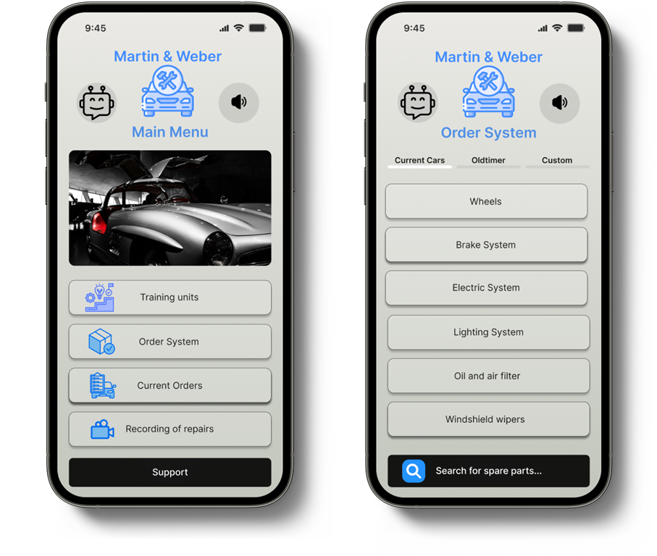The inclusion of a high-quality image of a classic car in the background adds a visual aesthetic that appeals to the target audience of classic car enthusiasts. This not only reinforces the brand identity, but also increases the visual appeal of the app, which in turn improves the user experience. The clear, bright background color ensures that all elements are easy to read, which increases usability.

Fig. 4‑1: Main Menu and Order System Mockups

The concept leverages interactivity and user engagement to enhance the learning experience in automotive repair. Incorporating modern web design principles, such as clean aesthetics and intuitive navigation, will ensure that users of all skill levels find the platform approachable and easy to use.

The design of the Order System is a well-designed segmentation of the different vehicle categories and related spare parts. Users can choose between “Current Cars”, “Oltimer” and “Custom”, which allows for a personalized experience by simplifying the search and ordering of specific parts. This categorization helps users navigate through inventory efficiently, which is invaluable in a repair shop where time is often a critical factor.

Each category is further subdivided into specific system components such as “Wheels”, “Brakes”, “Electrical System”, allowing for quick and targeted navigation. This clear structure is crucial to increase efficiency in the workflow. The search bar at the bottom of the screen is always accessible and allows for quick searches, which is a time-saving component that is highly appreciated in fast-paced work environments.

The clear visual hierarchy, intuitive navigation and responsive design of each element ensure that the app is not only functional but also easy to use. The consistent use of colors, typography and graphic elements helps create a cohesive environment that builds user confidence and promotes efficient use. Opportunities for improvement could lie in further personalizing the user experience, for example through customizable interfaces or through extended filter options in the ordering system to further increase efficiency.

### AR-Headset

Ein Bild, das Person, Maschine, Kleidung, Bautechnik enthält.
The interactive dashboard is designed to enhance the user's experience with features like Live Data Overlay, which displays real-time diagnostics, sensor data, and mechanical statistics directly over the car parts being viewed. Additionally, the system includes Tool Recognition, which identifies tools in view and suggests their uses based on the task at hand.

Fig. 4‑2: Training Situation with AR-Application

Step-by-Step Tutorials further support the user, offering visual instructions that align with the physical components within the user’s view. These tutorials are designed with Adjustable Complexity Levels, allowing users to select the instruction complexity that matches their skill level, catering to both novices and experienced technicians. The Diagnostic Tools segment leverages augmented reality to highlight issues and suggest the most likely fixes, integrating seamlessly with car diagnostics to provide a streamlined troubleshooting experience.

Ein Bild, das Person, Kleidung, Fahrzeug, Landfahrzeug enthält.
Training Modules are an integral part of the system, featuring Skill Assessments that include quizzes to reinforce learning and validate the repair techniques acquired. Progress Tracking is also implemented to monitor and log progress, offering feedback and additional resources tailored to the learner’s performance.

Fig. 4‑3: Training Situation with AR-Application

Lastly, the Support and Integration features bolster the learning environment with Remote Expert Support, enabling learners to connect with experts in real-time for guidance during complex repair tasks. A Feedback Mechanism is also incorporated, allowing users to rate tutorials and suggest improvements, ensuring the system evolves in response to user needs and enhances the learning experience.

## Usability and User Experience

The user interface for the repair and documentation support project for the Martin & Weber car repair business should meet specific requirements. This includes a simple and intuitive user interface that enables employees to work more efficiently without extensive IT knowledge. The user interface should include clear instructions and real-time feedback to facilitate the use of AR functions. In addition, the interface must be compatible with different types of devices, which in the context of this project are smartphones and AR glasses, such as the Magic Leap 2. The usability heuristics according to Nielsen and the ISO standard 9241-11 are used to develop a target-oriented and appealing design (Mack und Nielsen, 1995).

Interactive repairs are also to be integrated by displaying step-by-step instructions for the vehicle to be repaired. These instructions will offer the possibility to visually display information and diagnoses in real-time and thus improve the precision and understanding of the repairs. For basic understanding, training modules will be integrated for new employees, accessible via AR technology or mobile devices. To ensure accessibility and accessibility, various customization options will be implemented for users to adapt the virtual elements and language according to their preferences.

In terms of integration and adaptability, the app will be based on Martin & Weber's existing design and corporate identity. In addition, it will be possible to connect to specific APIs to enable the exchange of information with classic car communities or spare parts stores, for example. The design of the user interface focuses on a high degree of user-friendliness and increasing the efficiency of the repair processes, which is particularly beneficial for Martin & Weber employees who work with different types of vehicles daily.

## Technological Design

In simple terms, technological design for an AR (augmented reality) add-on in a car repair shop involves figuring out the best way to use technology to make the AR system work smoothly and effectively. Here's more detail about it.

### Selecting the Right Hardware

Selecting the right hardware for the AR system is like choosing the perfect tool from a toolbox. We want to pick devices, such as smart glasses or tablets, that mechanics will find comfortable and efficient to use. Just like how a painter or carpenter the right hammer for the job, we need hardware that's reliable, durable, and easy to handle. These devices should be user-friendly, with interfaces that mechanics can navigate with ease, ensuring they can focus on the repairs without getting bogged down by complicated technology.

### AR Software

Choosing AR software is similar to picking apps for your phone. We need to select software that creates a smooth and user-friendly AR experience. Just like how you choose apps that are easy to use and provide helpful features, we want AR software that displays clear and helpful overlays on top of the real world, making it easy for mechanics to understand and use during repairs.

### Integration with existing systems

Integration with existing systems is like making sure all the pieces of a puzzle fit together perfectly. Our AR system needs to work seamlessly with other systems already in place in the repair shop, like databases or management software. This ensures that information flows smoothly between different parts of the repair process, making everything more efficient and effective. It's all about ensuring that the AR system enhances, rather than disrupts, the workflow of the repair shop.

### Ensuring Compatibility and Performance

Ensuring compatibility means making sure the AR system works smoothly with different devices and operating systems that mechanics might use. It's like making sure a new game works on all types of gaming platforms, which everyone to be able to use without any issues. This ensures that mechanics can access the AR system no matter what device they prefer, whether it's a tablet, smartphone, or smart glasses. Considering performance involves making sure the AR system runs smoothly without any lag or glitches. It's like making sure a video streams smoothly on your phone – we want mechanics to have a seamless experience while using the AR system. This means the AR software should be optimized to work efficiently on different devices, providing mechanics with real-time information and overlays without any delays or disruptions.

### Addressing Security Concerns

Just like you'd want to keep your personal information safe on your phone, we need to ensure that the AR system protects mechanics' data from unauthorized access. This means using advanced techniques like encryption to scramble the data, making it unreadable to anyone who shouldn't have access.

### Providing Technical Support

Just as you'd want help if your phone stopped working, mechanics should have access to assistance if they run into any problems with the AR system. This means having a dedicated support system in place, like a customer service hotline, where mechanics can reach out for help and get their issues resolved quickly. It's all about making sure mechanics feel supported and confident using the AR system, just like you'd expect with any other piece of technology.

## Test Scenarios

In this Testing case, a set of automated and Manual test cases are running under the dedicated teams, All the Testing teams are responsible for performing tests providing the test data and developing automated tests.

### Unit tests

Unit testing is the First layer of testing, every dedicated developer of the team is solely responsible because there is a lot of manual coding involved in unit testing. the unit testing takes place before the launch or release. The unit tests are determined by the used.

classes and the corresponding methods.

### Components tests

Component testing is done automatically with software support. After Unit Testing is performed, the next testing is component testing. Component testing is done by the testers who push the code to the automated infrastructure provided by the DevOps team.

### Integration Tests

Integration tests are performed more often, and more quickly as new features or changes are added to the software. Dedicated Developers and Testers worked together in this phase and are responsible for system integration testing. In this testing, the DevOps Team deploys testing under CI/CD, which helps how different modules and services work within the application. The testers will take help from the Product Owner or business analyst for help in developing the test scenarios and reviewing the cases.

### System Tests

System Testing is performed by a testing team manually that is independent of the development team, but in system testing people like Software Testers, Q&A Analysts, Acceptance Testers, and others are involved they typically conduct system testing after it checks individual modules with functional or user story testing and then each component through integration testing.

# Project Planning

## Project Management Methodology

We have decided to adopt the Agile methodology in software development due to its numerous benefits. The Agile methodology prioritizes rapid and frequent software delivery, ensuring that we can provide Martin & Weber with valuable features more quickly. This is achieved using shorter development cycles, which typically last between two weeks to two months. Through feedback loops and iterations, product quality and value are improved, and as a result, valuable features can be made available to Martin & Weber sooner. By gathering frequent feedback from Martin and Weber, we can enhance the product and speed up its delivery.

The main objective of Agile is to deliver valuable software early and continuously, ensuring customer satisfaction, which in turn, helps us keep Martin and Weber happy.

We are using the Scrum method. Scrum offers numerous benefits to Martin & Weber.

**1. Frequent Delivery:** By breaking down the development process into short sprints, the Scrum team can deliver valuable features regularly, ensuring that Martin & Weber can see tangible progress regularly.

**2. Feedback Loops:** The regular interaction between the Scrum team and Martin & Weber ensures that their requirements are understood and incorporated into the product quickly. This approach leads to higher satisfaction levels and ensures that Martin & Weber's needs are met effectively.

**3. Continuous Improvement:** The iterative nature of Scrum, with its sprint reviews and retrospectives, allows the team to continuously improve both the product and the development process. This approach ensures that Martin & Weber's needs are met effectively and that they receive a product that exceeds their expectations.

Fig. 5‑1: Agile Methodology Circle

## Execution Methodology

As part of the Scrum methodology, we divide each development phase into four-week sprints, within which we define specific goals and results. In order to maintain an overview and be able to react promptly to challenges, we hold short daily meetings, known as daily stand-ups. Sprint reviews are held at the end of each sprint to review the work done to ensure that it meets the customer's requirements.

Another key component of our method is continuous integration and delivery. Through automated builds and tests, we ensure that integrations are frequent and error-free, which constantly improves the quality of the end product.

In terms of user-oriented development, we rely on prototyping and the creation of minimal viable products (MVPs). By publishing these prototypes and MVPs early and regularly, we collect valuable feedback from end users, which flows directly into further development. We use this direct feedback, especially from the technicians at Martin & Weber, to continuously optimize the user experience.

Finally, involving and communicating with key stakeholders is a central aspect of our project management. We keep everyone involved, including the client team and end users, informed of progress and changes to the project through regular updates. The project plan is designed to be flexible and is regularly updated and reviewed against milestones to best respond to changing requirements and priorities. Using an agile methodology offers significant benefits, including flexibility, improved end-user satisfaction and efficient use of resources. This ensures that the project not only meets the technical requirements, but also increases operational efficiency for our Martin & Weber Shop client and maximizes user adoption.

## Controlling Methodology

Milestone trend analysis was chosen as the methodology for controlling the project. This method is suitable for providing a precise overview of when milestones should be reached in agile project developments. Figure 5-2 below shows the control instance based on the planned sprints for the standard package in section 5.6. The diagram can be quickly adapted to the planned sprints for the premium package.

Ein Bild, das Text, Screenshot, Diagramm, Reihe enthält.

Fig. 5‑2: Prepared Milestone Trend Analysis Chart

The chart shows four key milestones planned over a period from May to July. The critical path of the project is represented by the red line that extends from one milestone to the next, highlighting key points in time as the project progresses. This shows that each of the four milestones is critical to the project's schedule and delays to any of these milestones would likely affect the overall project schedule and end date.

The different sprints - Sprint 0, Sprint 1, Sprint 2 and Sprint 3 - are represented by different colors and run parallel to the reporting dates, which are marked as red dots on a horizontal axis at the bottom of the graph. The chronological positioning and sequence of the sprints indicate that each sprint comprises specific goals and tasks that must be fulfilled to successfully reach the subsequent milestones.

The product launch is represented by a green line positioned at the end of the diagram, indicating that the product will be launched after the last sprint has been completed and all milestones have been met.

The effective use of such an MTA chart in an IT project allows the management team to make adjustments in real time should project progress slow down or accelerate, and helps to improve transparency and communication with project stakeholders to ensure successful project delivery.

## User Stories and Epics

The user stories cover a range of tasks, from basic functionalities like logging in and registering for an account to more complex tasks such as recording critical repairs and providing technical support. Each user story is prioritized based on its importance and complexity, which helps the development team allocate resources effectively.

Overall, this approach helps to break down the development process into smaller, manageable tasks, making it easier to plan, prioritize, and track progress. It also ensures that the development team remains focused on delivering value to users by meeting their specific needs and requirements outlined in the user stories. The detailed User Stories and Epics are in the Appendix in section K and L.

## Project Structure and Network Plan

### Product Structure Plan

Fig. 5‑2: Structure Plan

Fig. 5‑3: Structure Plan

## Sprints

### Sprints for mobile Development

|  |  |  |  |  |  |  |  |
| --- | --- | --- | --- | --- | --- | --- | --- |
| Order | Epic | User Story | Dependency | Duration (days) | Estimated Sprint | Moscow | Complexity |
| 3 | 0 | 0.1 | 0.2, 0.4 | 7 | 0 | Must | 13 |
| 2 | 0 | 0.2 | 0.4 | 2 | 0 | Must | 3 |
| 5 | 0 | 0.3 | 0.1, 0.2,0.4, 0.5 | 2 | 0 | Must | 3 |
| 1 | 0 | 0.4 | None | 5 | 0 | Must | 5 |
| 4 | 0 | 0.5 | 0.2, 0.4 | 4 | 0 | Must | 8 |
| 9 | 1 | 1.1 | 1.6 | 12 | 1 | Must | 13 |
| 10 | 1 | 1.2 | 1.6 | 5 | 1 | Must | 5 |
| 13 | 1 | 1.3 | E1 | 10 | 2 | Must | 13 |
| 11 | 1 | 1.4 | 1.6,1.2 | 10 | 2 | Must | 8 |
| 7 | 1 | 1.5 | 1.6 | 1 | 1 | Must | 1 |
| 6 | 1 | 1.6 | None | 1 | 1 | Must | 1 |
| 8 | 1 | 1.7 | 1.6 | 1 | 1 | Must | 1 |
| 9 | 2 | 1.8 | E1 | 8 | 3 | Must | 13 |

Tab. 5‑1: Sprints in mobile Development

### Sprints for Augmented Reality

|  |  |  |  |  |  |  |  |
| --- | --- | --- | --- | --- | --- | --- | --- |
| Order | Epic | User Story | Dependency | Duration (days) | Estimated Sprint | Moscow | Complexity |
| 3 | 0 | 0.1 | 0.2, 0.4 | 7 | 0 | Must | 13 |
| 2 | 0 | 0.2 | 0.4 | 2 | 0 | Must | 3 |
| 5 | 0 | 0.3 | 0.1, 0.2,0.4, 0.5 | 2 | 0 | Must | 3 |
| 1 | 0 | 0.4 | None | 5 | 0 | Must | 5 |
| 4 | 0 | 0.5 | 0.2, 0.4 | 4 | 0 | Must | 8 |
| 9 | 1 | 1.1 | 1.6 | 12 | 1 | Must | 13 |
| 10 | 1 | 1.2 | 1.6 | 5 | 1 | Must | 5 |
| 13 | 1 | 1.3 | E1 | 10 | 2 | Must | 13 |
| 11 | 1 | 1.4 | 1.6,1.2 | 10 | 2 | Must | 8 |
| 7 | 1 | 1.5 | 1.6 | 1 | 1 | Must | 1 |
| 6 | 1 | 1.6 | None | 1 | 1 | Must | 1 |
| 8 | 1 | 1.7 | 1.6 | 1 | 1 | Must | 1 |
| 9 | 2 | 2.1 | E0, 1.6 | 3 | 3 | Must | 3 |
| 10 | 2 | 2.2 | 2.1 | 5 | 3 | Must | 8 |
| 11 | 2 | 2.3 | 2.1, 2.2 | 8 | 3 | Must | 8 |
| 12 | 2 | 2.4 | None | 4 | 3 | Must | 5 |
| 12 | 2 | 2.4 | None | 4 | 4 | Must | 5 |
| 13 | 2 | 2.5 | E0, E1, 2.1,2.2,2.3 | 7 | 4 | Must | 13 |
| 15 | 2 | 2.6 | E0, E1, E2 | 5 | 4 | Must | 13 |
| 16 | 2 | 2.7 | E1 | 4 | 4 | Must | 13 |
| 17 | 2 | 2.7 | E1 | 11 | 5 | Must | 13 |

Tab. 5‑2: Sprints in AR Development

## Time Planning

This section highlights the synchronization of timing with the agile sprint cycles that form the basis of our project's execution methodology. Our approach begins with an initialization phase that sets the framework for the successive sprints that drive the development of our augmented reality (AR) and mobile application functionalities.

In the initial phase, we take four to five weeks to define the scope of the project, the goals and the user stories, and to build the technical infrastructure for the upcoming sprints. Sprint 0 is then carried out over one to two weeks, focusing on the creation of the MVP (Minimum Viable Product) or prototype, depending on the previously identified core requirements.

The main development phase consists of four-week sprints. Each sprint begins with a planning session in which specific user stories are selected for development. The sprints are designed to be dynamic and responsive, allowing for adjustments based on daily stand-up meetings, sprint reviews and retrospectives that ensure the project remains aligned with stakeholder expectations and technical goals. The sprints for mobile development and the AR-specific sprints described in section 5.6, for example, are crucial for achieving the project milestones. These include the integration of AR functionalities and compatibility with mobile devices, which are crucial for the usability of the system in the context of the vehicle workshop. The sprints are detailed with dependencies, duration and complexity levels, which help the development teams to prioritize tasks and allocate resources effectively.

Release planning and the final project completion phase are the last parts of our scheduling strategy. Release planning takes place as required - either after significant development progress or at the end of each sprint - to ensure a smooth transition and integration of the developed functions into Martin & Weber's existing systems. Documentation, quality assurance and handover processes are completed in the one to two-week project completion phase.

This schedule is not only in line with the agile methods described in section 5.6, but also improves our ability to manage the project efficiently, ensure on-time delivery within budget and scope, and thus meet or exceed all technical and business expectations. This comprehensive scheduling strategy is critical to maintaining the integrity and coherence of the project and ensures that all components work seamlessly together to achieve the desired end results for the Martin & Weber Shop.

## Budget Planning

At the beginning, the customer expressed the wish to have a choice of the desired functions. The reason for this is that the customer has a small workshop and therefore cannot afford the costs for the AR functions and their hardware.

**Standard package:**

A preliminary budget was drawn up for the standard package based on the previous analyses and schedules. This is explained below.

The financial planning for the project is divided into several phases, starting with initialization and planning. Sprint 0 lasts four to five weeks and includes expenses of €40,000 for the creation of the product backlog, market analyses and strategic planning, including salaries for project managers and analysts. In this phase, the technical infrastructure and working environment are set up and a prototype or minimum viable product (MVP) is developed, including the necessary software licenses and hardware purchases.

The actual development phase consists of several sprints, each lasting two to four weeks and costing around €80,000 per sprint. These costs cover the salaries of the development teams, the ongoing operating costs and the tools. A total of four sprints are planned, so the costs amount to €320,000. A further €10,000 is required for release planning, which is carried out either after each significant advance or at the end of a sprint, depending on requirements. These funds are earmarked for release management and marketing to support the market launch.

The project ends with a one- to two-week closing phase, during which €20,000 is spent on documentation, final quality assurance and preparation for the project handover. The total costs of the project therefore amount to around €380,000. This sum covers all phases of agile development and includes a reserve of 10% for unforeseen expenses, which supports the necessary adaptability during the project.

**Premium package:**

Additional investments in research and development for the augmented reality application are planned for the premium package. This results in three additional sprints, each of which is calculated at €160,000. These costs therefore amount to €480,000 and will be used for the development of extended functions such as improved sensors and interactive display technologies. This phase includes both technical development and the integration of new software functions. The standard package forms the basis for this system and takes over its design.

In addition, a further €30,000 has been earmarked for prototype development and testing. These funds will be used to procure specific components and carry out extensive tests to ensure the functionality and user-friendliness of the AR glasses. A further €5,000 is earmarked for licensing and the associated license fees. These costs serve to legally secure the newly developed technologies and their applications.

Overall, these additional measures increase the total costs by €525,000, bringing the projected total costs for the project to €895,000. These investments are crucial to increase the efficiency of the AR glasses and to ensure that the product meets the high technological requirements as well as the expectations of the end users.

## Stakeholder and Risk Management

As part of the Scrum methodology, we divide each development phase into four-week sprints, within which we define specific goals and results. In order to maintain an overview and be able to react promptly to challenges, we hold short daily meetings, known as daily stand-ups. Sprint reviews are held at the end of each sprint to review the work done to ensure that it meets the customers’ requirements.

Another key component of our method is continuous integration and delivery. Through automated builds and tests, we ensure that integrations are frequent and error-free, which constantly improves the quality of the end product.

In terms of user-oriented development, we rely on prototyping and the creation of minimal viable products (MVPs). By publishing these prototypes and MVPs early and regularly, we collect valuable feedback from end users, which flows directly into further development. We use this direct feedback, especially from the technicians at Martin & Weber, to continuously optimize the user experience.

Finally, involving and communicating with key stakeholders is a central aspect of our project management. We keep everyone involved, including the client team and end users, informed of progress and changes to the project through regular updates. The project plan is designed to be flexible and is regularly updated and reviewed against milestones to best respond to changing requirements and priorities. Using an agile methodology offers significant benefits, including flexibility, improved end-user satisfaction and efficient use of resources. This ensures that the project not only meets the technical requirements, but also increases operational efficiency for our Martin & Weber Shop client and maximizes user adoption.

# Executive Summary

This executive summary outlines the implementation of an augmented reality (AR) supported repair and documentation system for Martin & Weber, a small automotive repair shop. The project utilizes cutting-edge AR and mobile technology to boost operational efficiency, enhance training, and improve customer service. Key features include an interactive AR interface for real-time visualization of repair processes, mobile device compatibility for seamless operation, AR-driven training modules to reduce learning curves, and automated inventory and billing systems to streamline operations.

The project is set to roll out in phases starting with an initial development sprint in May 2024, leading to a full product launch by July 2024. Total costs are projected at €380,000 for the standard package, with an advanced package estimated at €895,000 due to additional functionalities and sprints. Major risks include technical challenges with AR hardware, potential delays in development, budget overruns, and compliance issues, with proactive risk management strategies such as regular stakeholder engagement, agile project management, comprehensive testing, and continuous legal reviews in place to address these concerns.

The AR system aims to revolutionize automotive repairs for the Martin & Weber Shop by enhancing service quality and operational efficiency, setting a foundation for future growth and replication in similar settings. Successful project execution, aligned with strategic goals and effective risk mitigation, will be key to realizing these ambitions.

# Appendix

## Personas

Ein Bild, das Text, Screenshot, Person enthält.
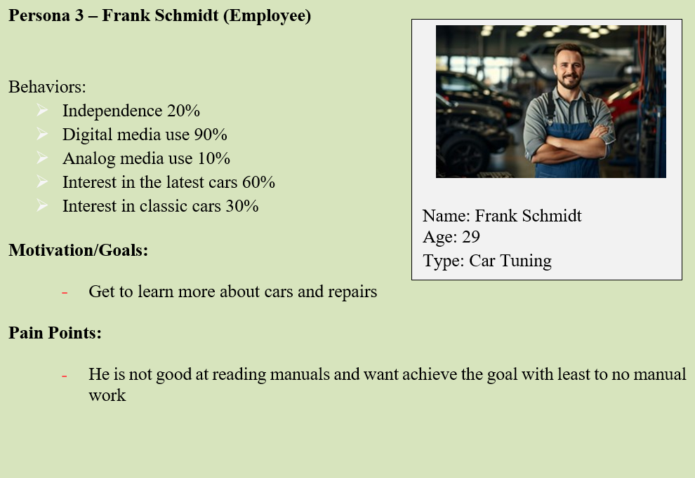

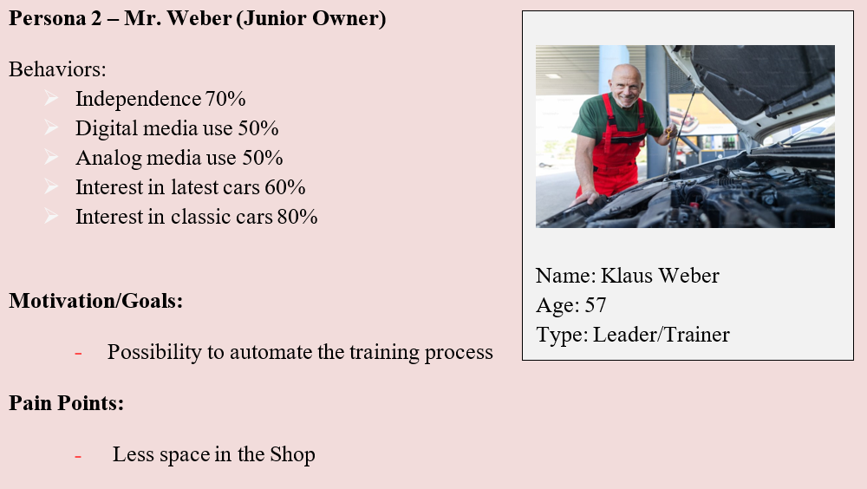

## Use Cases: Usage Flow of mobile App

## Use Cases: Usage Flow of AR-Headset

## Technical Risks

|  |  |  |  |  |
| --- | --- | --- | --- | --- |
| ID | Description | Probability of occurrence | Consequences | |
| TR1 | System or App connection is lost | 40% | | No manual training.  No trainee support.  Long-expected servicing’s. |
| TR2 | Incorrect allocation of information within the system can lead to errors or disrupt the current functioning of the car. | 50% | | High risk of main part damages and if not resolved it leads to car accidents. |
| TR3 | If AR hardware fails, important repair processes could be interrupted, which can lead to business interruptions. | 20% | | No manual service possible for critical repairs.  Longtime Resolution. |

## Project Environment Risks

|  |  |  |  |
| --- | --- | --- | --- |
| ID | Description | Probability of occurrence | Consequences |
| PER1 | Stakeholders or responsible Persons change | 15% | Different decision making.  New Requirements. |
| PER2 | Leadership changes in Government | 20% | Project Break-off.    Affects Focus of the project. |
| PER3 | Undefined Requirements detected in case the Project Environment changes | 30% | Unsuccessful Project.  New Requirements. |

## Safety Risks

|  |  |  |  |
| --- | --- | --- | --- |
| ID | Description | Probability of occurrence | Consequences |
| SR1 | Operating heavy machinery and equipment poses risks. Regular maintenance, proper training, and safe operating procedures are critical | 20% | Machinery Damage and Investment loss. |
| SR2 | The operations involve significant earth moving and construction, posing risks to the local environment, including potential pollution and habitat disruption. The presence of heavy machinery and equipment such as crushers and loaders indicates a risk of mechanical failure or operational inefficiencies | 25% | Increased repair costs and Project Delays. |
| SR3 | AR hardware is often expensive and could be a target for theft or damage | 40% | Investment Loss due to robbery. |
| SR4 | AR applications can potentially expose the system to security threats such as data breaches or malware, especially if these applications are not properly secured or if they access insecure networks | 25% | Cyber-attacks and malicious content attacks. |

## Business Risks

|  |  |  |  |
| --- | --- | --- | --- |
| ID | Description | Probability of occurrence | Consequences |
| BR1 | Revenue goals could not be reached | 50% | Product quality deficiencies.  Staff Layoffs. |
| BR2 | Competitors could come up with an alternative solution | 70% | Company cannot reaches it goals.  Company can lose the project. |
| BR3 | Innovations in Augmented Reality Systems make systems obsolete | 10% | Company will not reach business goals. |
| BR4 | The complexities and potential delays in projects of this scale carry the risk of budget overruns, impacting financial forecasts | 40% | Customer might deny more budget requirements.  Company will not reach business goals. |
| BR5 | More time is needed as expected | 40% | Company will not reach business goals. |
| BR6 | Failure to meet project milestones will have an impact on the stakeholder relations and project approvals | 15% | Project delays.  Project failure. |

## Planning Risks

|  |  |  |  |
| --- | --- | --- | --- |
| ID | Description | Probability of occurrence | Consequences |
| PR1 | Documentation takes more time than planned | 65% | Project delays.  Quality deficiencies in Documentation. |
| PR2 | Lack of specialists | 20% | Project delays.  Quality issues.  Project failure. |
| PR3 | Change management processes take more time than expected or there are necessary changes identified while implementing | 70% | Project delays.  Some changes which are not so important can be skipped which leads to future problems. |
| PR4 | Testing takes more time | 50% | Project delays.  Developments and iterations might get paused. |
| PR5 | Mistakes in the Concept were detected in late project phases | 25% | Milestones cannot be reached.  Resources are completely used. Project fails. |

## Environmental Risks

|  |  |  |  |
| --- | --- | --- | --- |
| ID | Description | Probability of occurrence | Consequences |
| ER1 | With complex projects like this, there is a risk of non-compliance with various environmental, safety, and construction regulations, which could result in fines and project delays. | 60% | Environmental Damage.  Reputational Damage.  Fines and Penalties. |
| ER2 | Not all European or National Laws and Regulations were identified/planned | 40% | Project Delays and Disruptions.  Stakeholder Dissatisfaction.(Including clients, Investors, etc) |
| ER3 | European or National Laws and Regulations have been misunderstood | 50% | Reputational Damage.  Financial losses.  Legal Penalties. |

## Risk Classification and Mitigation Strategies

|  |  |  |  |  |  |
| --- | --- | --- | --- | --- | --- |
| No. | Mitigate | Omit | Delegate | Accept | Solution |
| TR1 | **X** |  |  |  | We will use mobile network, Internet |
| TR2 |  |  |  | **X** | We are delivering highly tested software where we have spent time testing |
| TR3 | **X** |  |  |  | We will equip the facility with backup AR devices to ensure that there is no interruption in the repair processes in case the primary AR hardware fails. This allows technicians to quickly switch to a backup device without losing significant time or compromising the repair process |
| PER1 | **X** |  |  |  | Inclusion in stakeholders information flow |
| PER2 | **X** |  |  |  | Inclusion in stakeholders information flow |
| PER3 | **X** |  |  |  | Refining and validating requirements through iteration is important to minimize errors and meet desired specifications. |
| SR1 | **X** |  |  |  | Train and certify operators to use heavy machinery. Establish clear operating procedures and safety protocols for all equipment. Communicate instructions to staff and enforce adherence |
| SR2 | **X** |  |  |  | Train and certify operators to use heavy machinery. Establish clear operating procedures and safety protocols for all equipment. Communicate instructions to staff and enforce adherence |
| SR3 |  |  | **X** |  | Get comprehensive insurance coverage for AR hardware to minimize financial losses due to theft or damage. The policy should cover replacement costs and any loss of business that may result from the unavailability of critical equipment. |
| SR4 | **X** |  |  |  | Regularly update your AR applications and underlying systems with the latest security patches to defend against new threats. |
| BR1 | **X** |  |  |  | Regularly review revenue targets to ensure they are realistic. |
| BR2 |  |  |  | **X** | Invest in R&D to improve your product and introduce new features to stay ahead of competitors. This maintains a competitive edge and makes it harder for competitors to catch up. |
| BR3 |  |  |  | **X** | Invest in R&D to improve your product and introduce new features to stay ahead of competitors. This maintains a competitive edge and makes it harder for competitors to catch up. |
| BR4 | **X** |  |  |  | Create a detailed budget accounting for all expenses and risks and set clear project milestones to monitor spending against deliverables. |
| BR5 | **X** |  |  |  | Utilise detailed project planning techniques such as work breakdown structures (WBS) to improve the accuracy of time estimations. This involves breaking down the project into smaller, manageable components and estimating the time required for each.  Add buffer times into the project schedule to accommodate unexpected delays. |
| BR6 | **X** |  |  |  | Ensure adequate resources are allocated for each task to meet the set milestones. This includes personnel, materials, and financial resources. |
| PR1 | **X** |  |  |  | Documentation is required.  Developers must do documentation within the code with comments. |
| PR2 | **X** |  |  |  | The Project is well documented. Therefore, necessary knowledge management reduces the risk of getting stuck without specialists. The use of very common technologies reduces the risk also. |
| PR3 | **X** |  |  |  | Proper Change Management is established in Conception with stakeholders and as a Change advisory board within the implementation phase |
| PR4 | **X** |  |  |  | Unit and component testing is automated via software and takes there for a reasonable and predictable amount of time |
| PR5 |  |  | **X** |  | Mistakes in the concept are transferred to the Stakeholders because they define the requirements. |
| ER1 | **X** |  |  |  | Conduct a thorough analysis of all applicable regulations and standards at the beginning of the project. This includes local, state, national, and industry-specific regulations that impact environmental, safety, and construction aspects. |
| ER2 |  |  | **X** |  | Hire or consult with legal experts who specialize in the specific sectors and regions relevant to the project. These experts can provide comprehensive insights into European and national laws that apply to the project. |
| ER3 |  |  | **X** |  | Hire or consult with legal experts who specialize in the specific sectors and regions relevant to the project. These experts can provide comprehensive insights into European and national laws that apply to the project. |

## Epics – Mobile Application

|  |  |  |  |
| --- | --- | --- | --- |
| Epic #0: Environment | | | |
| User Story  #0.1 | Priority:  High | Complexity:  13 | Team:  Dev |
| As a developer,    I want the initial design to be completed. | | | |
| Acceptance criteria  Given that the high-level architecture and design of the system are defined, the initial design is completed. | | | |
| User Story  #0.2 | Priority:  High | Complexity:  3 | Team:  Dev |

|  |  |  |  |
| --- | --- | --- | --- |
| As a developer  I need to define the roles | | | |
| Acceptance criteria  Once we bring together the necessary team members, roles can be defined as per the expertise of each team members | | | |
| User Story  #0.3 | Priority:  Must /high | Complexity:  3 | Team:  Dev |
| As a developer  I want to do initial planning | | | |
| Acceptance criteria  Given that the requirements are known, High-level planning for the upcoming sprints, including defining the project scope, setting goals, and identifying potential risks is done | | | |
| User Story  #0.4 | Priority:  Must /high | Complexity:  5 | Team:  Dev |
| As a developer  I need sufficient information about the user's requirements before I can begin developing | | | |
| Acceptance criteria  Given that the requirements are gathered and aligned with the customer, development can commence. | | | |
| User Story  #0.5 | Priority:  Must /high | Complexity:  8 | Team:  Dev |
| As a developer  I want the system infrastructure to be set up so that I can start app web and system development | | | |
| Acceptance criteria  Given that the system infrastructure is in place and basic functions are available, actual development can commence. | | | |

|  |  |  |  |
| --- | --- | --- | --- |
| Epic #1: User | | | |
| User Story  #1.1 | Priority:  High | Complexity:  13 | Team:  Dev |
| As a user  I should be able to upload the training videos with ease on the application. | | | |
| Acceptance criteria  Given that the user has successfully logged into the system, he will be able to upload the training videos | | | |
| User Story  #1.2 | Priority:  Must /high | Complexity:  5 | Team:  Dev |

|  |  |  |  |
| --- | --- | --- | --- |
| As a user  I should be able to get customer support | | | |
| Acceptance criteria  Given that the user has logged in and paired the device, customer support is provided | | | |
| User Story  #1.3 | Priority:  Must /high | Complexity:  13 | Team:  Dev |
| As a user  I want to effortlessly generate billing based on the services and tools used | | | |
| Acceptance criteria  Given that the user has successfully logged into the system, he will be able to generate billing | | | |
| User Story  #1.4 | Priority:  Must /high | Complexity:  8 | Team:  Dev |
| As a user    I need to monitor and maintain the spare parts inventory to avoid repair delays. | | | |
| Acceptance criteria  Given that the user has successfully logged into the system, he will be able to monitor and maintain the spare parts | | | |

|  |  |  |  |
| --- | --- | --- | --- |
| User Story  #1.5 | Priority:  Must /high | Complexity:  1 | Team:  Dev |
| As a user  I want to be able to log in to the system using my registered email address and password. | | | |
| Acceptance criteria  Given that the user is registered, he should be able to login to the system | | | |

|  |  |  |  |
| --- | --- | --- | --- |
| User Story  #1.6 | Priority:  Must /high | Complexity:  1 | Team:  Dev |
| As a user  I want to be able to register for an account with my email address and password. | | | |
| Acceptance criteria  Given that the user has a device and has accepted the services, registration could be done | | | |

|  |  |  |  |
| --- | --- | --- | --- |
| User Story  #1.7 | Priority:  Must /high | Complexity:  1 | Team:  Dev |
| As a user  I want to be able to reset my password. | | | |
| Acceptance criteria  Given that the user has successfully registered to the system, he will be able to reset the password | | | |
| User Story  #1.8 | Priority:  Must /high | Complexity:  13 | Team:  Dev |
| As a developer  I should be able to test the entire application | | | |
| Acceptance criteria  Given that the application is successfully developed, testing would be done for all possible scenarios. | | | |

## Epics – AR-Application

|  |  |  |  |
| --- | --- | --- | --- |
| Epic #0: Environment | | | |
| User Story  #0.1 | Priority:  High | Complexity:  13 | Team:  Dev |
| As a developer  I want the initial design to be completed. | | | |
| Acceptance Criteria  Given that the high-level architecture and design of the system are defined, the initial design is completed. | | | |
| User Story  #0.2 | Priority:  High | Complexity:  3 | Team:  Dev |

|  |  |  |  |
| --- | --- | --- | --- |
| As a developer  I need to define the roles | | | |
| Acceptance criteria  Once we bring together the necessary team members, roles can be defined as per the expertise of each team members | | | |
| User Story  #0.3 | Priority:  Must /high | Complexity:  3 | Team:  Dev |
| As a developer  I want to do initial planning | | | |
| Acceptance criteria  Given that the requirements are known, High-level planning for the upcoming sprints, including defining the project scope, setting goals, and identifying potential risks is done | | | |
| User Story  #0.4 | Priority:  Must /high | Complexity:  5 | Team:  Dev |
| As a developer  I need sufficient information about the user's requirements before I can begin developing | | | |
| Acceptance criteria  Given that the requirements are gathered and aligned with the customer, development can commence. | | | |
| User Story  #0.5 | Priority:  Must /high | Complexity:  8 | Team:  Dev |
| As a developer  I want the system infrastructure to be set up so that I can start app web and system development | | | |
| Acceptance criteria  Given that the system infrastructure is in place and basic functions are available, actual development can commence. | | | |

|  |  |  |  |
| --- | --- | --- | --- |
| Epic #1: User | | | |
| User Story  #1.1 | Priority:  High | Complexity:  13 | Team:  Dev |
| As a user  I should be able to upload the videos with ease on the application | | | |
| Acceptance criteria  Given that the user has successfully logged into the system, he will be able to upload the videos | | | |
| User Story  #1.2 | Priority:  Must /high | Complexity:  5 | Team:  Dev |

|  |  |  |  |
| --- | --- | --- | --- |
| As a user  I should be able to get customer support | | | |
| Acceptance Criteria  Given that the user has a logged in and paired the device, customer support is provided | | | |
| User Story  #1.3 | Priority:  Must /high | Complexity:  13 | Team:  Dev |
| As a user  I want to effortlessly generate billing based on the services and tools used | | | |
| Acceptance criteria  Given that the user has successfully logged into the system, he will be able to generate billing | | | |
| User Story  #1.4 | Priority:  Must /high | Complexity:  8 | Team:  Dev |
| As a user  I need to monitor and maintain the spare parts inventory to avoid repair delays. | | | |
| Acceptance criteria  Given that the user has successfully logged into the system, he will be able to monitor and maintain the spare parts | | | |

|  |  |  |  |
| --- | --- | --- | --- |
| User Story  #1.5 | Priority:  Must /high | Complexity:  1 | Team:  Dev |
| As a user  I want to be able to log in to the system using my registered email address and password. | | | |
| Acceptance criteria  Given that the user is registered, he should be able to login to the system | | | |

|  |  |  |  |
| --- | --- | --- | --- |
| User Story  #1.6 | Priority:  Must /high | Complexity:  1 | Team:  Dev |
| As a user  I want to be able to register for an account with my email address and password. | | | |
| Acceptance criteria  Given that the user has a device and has accepted the services, registration could be done | | | |

|  |  |  |  |
| --- | --- | --- | --- |
| User Story  #1.7 | Priority:  Must /high | Complexity:  1 | Team:  Dev |
| As a user  I want to be able to reset my password. | | | |
| Acceptance criteria  Given that the user has successfully registered to the system, he will be able to reset the password | | | |

|  |  |  |  |
| --- | --- | --- | --- |
| User Story  #2.1 | Priority:  Must /high | Complexity:  5 | Team:  Dev |
| As a user  I should be able to pair the device | | | |
| Acceptance Criteria  Given that the user has AR glasses, he should be able to pair the device | | | |
| User Story  #2.2 | Priority:  Must /high | Complexity:  8 | Team:  Dev |
| As a user  I should be able to calibrate | | | |
| Acceptance criteria  Given that the user has logged in successfully and pairs the glasses with the smartphone, the user should be able to calibrate the glasses to ensure accurate tracking and alignment of virtual content with the real environment | | | |

|  |  |  |  |
| --- | --- | --- | --- |
| User Story  #2.3 | Priority:  Must /high | Complexity:  8 | Team:  Dev |
| As a user  I should be able to record critical repair | | | |
| Acceptance criteria  Given that the user logs in successfully and pairs the glasses with the smartphone, the user should be able to record critical repairs | | | |

|  |  |  |  |
| --- | --- | --- | --- |
| User Story  #2.4 | Priority:  Must /high | Complexity:  5 | Team:  Dev |
| As a user  I should be able to provide updated feature | | | |
| Acceptance criteria  Given that the user logs in successfully and pairs the glasses with the smartphone, the user should be able to get system updates | | | |

|  |  |  |  |
| --- | --- | --- | --- |
| User Story  #2.5 | Priority:  Must /high | Complexity:  13 | Team:  Dev |
| As a user  I should be able to communicate with the system in case I need any information | | | |
| Acceptance criteria  Given that the user logs in successfully and pairs the glasses with the smartphone and also the large language model is implemented, the user will be able to communicate with the system | | | |

|  |  |  |  |
| --- | --- | --- | --- |
| User Story  #2.6 | Priority:  Must /high | Complexity:  13 | Team:  Dev |
| As a user  I should be able to provide technical support | | | |
| Acceptance criteria  Given that the user logs in successfully and needs any technical help, technical support could be provided | | | |

|  |  |  |  |
| --- | --- | --- | --- |
| User Story  #2.7 | Priority:  Must /high | Complexity:  13 | Team:  Dev |
| As a developer  I should be able to test the entire application | | | |
| Acceptance criteria  Given that the application is successfully developed, testing would be done for all possible scenarios | | | |

# Literature and References for images

Mack, R.L. und J. Nielsen, 1995. Usability Inspection Methods: Executive Summary. In: *Readings in Human–Computer Interaction:* Elsevier, S. 170-181. ISBN 9780080515748.

Fig. 5-1: https://targettrend.com/agile-methodology-meaning-advantages-disadvantages-more/

Fig. 4-2: https://smarttek.solutions/blog/ar-in-the-automotive/#:~:text=AR%20Car%20Repair%20Assistance&text=Implementing%20an%20AR%20system%20allows,service%20instructions%2C%20and%20other%20information.

Fig. 4-3: https://www.bosch-presse.de/pressportal/de/de/augmented-reality-applikationen-beschleunigen-kfz-reparaturen-und-unterstuetzen-technische-trainings-130688.html

# Index of Figures

Fig. 3‑1: Main Menu and Order System Mockups 13

Fig. 3‑1: Risk Matrix 15

Fig. 4‑1: Main Menu and Order System Mockups 23

Fig. 4‑2: Training Situation with AR-Application 24

Fig. 4‑3: Training Situation with AR-Application 25

Fig. 5‑1: Agile Methodology Circle 31

Fig. 5‑2: Prepared Milestone Trend Analysis Chart 32

Fig. 5‑2: Structure Plan 34

Fig. 5‑3: Structure Plan 35

# Index of Tables

Tab. 1‑1: Team Roles and Responsibilities 5

Tab. 2‑1: Result Objectives Table 8

Tab. 3‑1: Result Objectives Table 13

Tab. 5‑1: Sprints in mobile Development 36

Tab. 5‑2: Sprints in AR Development 37